1. In order to help set appropriate speed limits we want to use data we have gathered on speeds and corresponding stopping distance to see if we can predict how long it will take someone to stop if they are going a given speed. We must know if the relationship between the speed and the stopping distance will allow us to make reasonable predictions. If we can find a statistical model that fits the data we will be able to predict, at a given speed, how long someone will travel before coming to a complete stop. This will help set speed limits that will be high enough to move the flow of traffic, but low enough to ensure that law-abiding citizens have plenty of room to come to a complete stop.

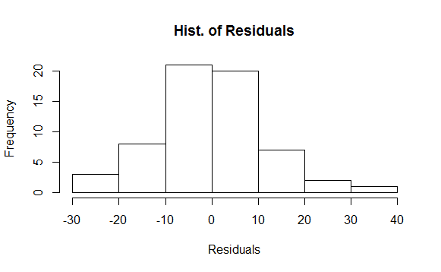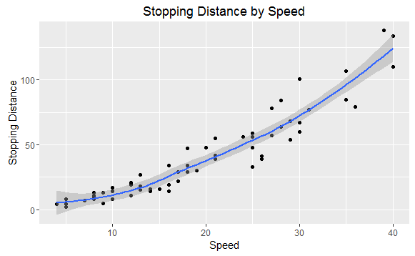2. We will use the data to assess if a simple linear regression model is suitable to analyze this data. Looking at the plot titled "Stopping Distance by Speed" we can see that there is a very strong linear relationship between Speed and Distance. A correlation of .937 also indicates this.

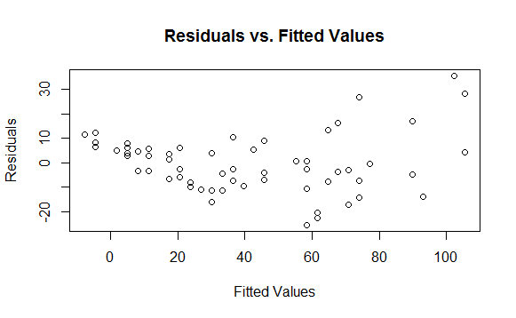Correlation: *r* = .937

The "Histogram of Residuals" tells us that the data are normally distributed, which is also needed. However, we have a problem when we look at the Residuals vs. Fitted Values plot. There is not an equal variance across the line and it looks like there may be some patterns in the data. The equal variance and independence assumptions are at risk. An SLR model on the raw data is not appropriate for this analysis because the assumption of equal variance is broken.

3.

i = β0 + β1i)+ εi where εi ~ N(0,σ2)

This model assumes linearity, normality, independence, and equal variance.

yi = observed value of the ith Pm

β0 = average square root stopping distance if the speed was 0 mph.

β1 = the average increase in the square root stopping distance as speed goes up by 1 mph

xi = speed you are using to predict the ith stopping distance

εi = the error associated with the ith observation

After fitting this model to the data, we will be able to provide an estimate of the true values of β0 and β1. Having the estimates for these parameters will allow us to predict the average stopping distance for any given speed.

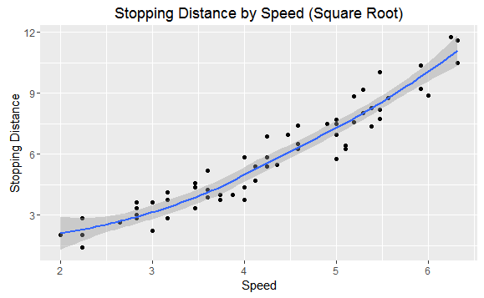4. We will use a square root transformation of the data to assess for the problems that we had with the equal variance assumption. We can see from the scatterplot to the right that we maintain linearity, and we can also tell from the histogram that we maintain normality. However, if we look at the "Residuals vs. Fitted Values (Square Root)" plot below you will notice how the variance is a lot more evenly distributed than originally with the raw data. This looks like our assumption of equal variance and independence is satisfied.

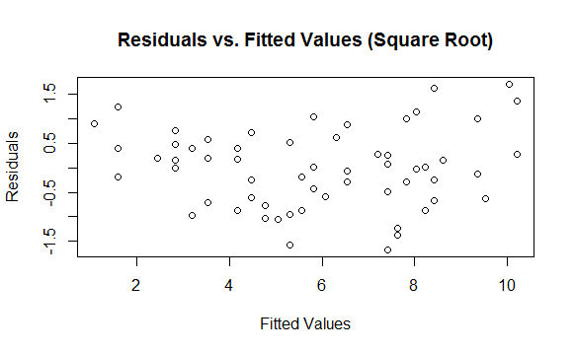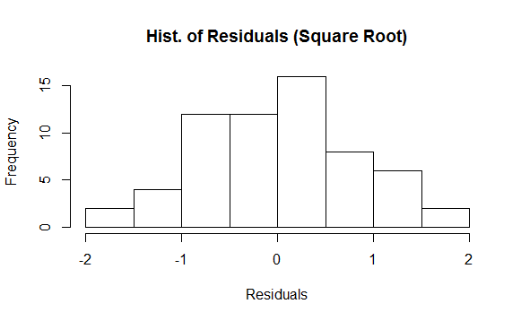

We can judge the how well this model fits the data by looking at R2 measure. With this model, we have an R2 of .9048, which means that roughly 90% of the variation in stopping distance can be explained by speed. This is a strong fit. We ran a simulation to measure our predictive accuracy as well. We found an average predictive bias of .0295, which means that we are not generally predicting too high or too low. This is good! We also found an average RPMSE of 10.347, which means that are about 10 feet off the true value on average.

5.

√i = -3.117 + 2.107i

0 = the average square root stopping distance for a speed of 0 is -3.177

1 = as the square root of the speed increases by 1 mph, the average increase in square root stopping distance is 2.107 feet.

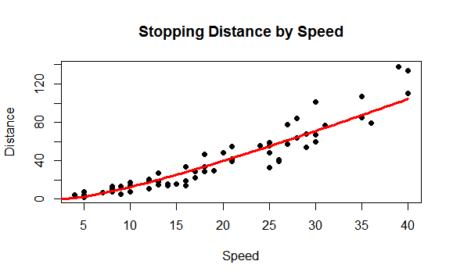

Fitted Regression Line on Original Data

6. Using this model, we will provide predictions for stopping distance at 30 mph, as well as 35 mph.

Speed = 30 mph → Predicted Stopping Distance = 70.96 feet

Speed = 35 mph → Predicted Stopping Distance = 88.38 feet

If you were to set the speed limit at 30 mph instead of 35 mph, you would have an average reduction of 18 feet in stopping distance. Given that this is a rural road with many homes, which means many children, I would recommend that you do not set the speed limit at 35 mph, but consider moving it down to 25-30 mph.